PIZZA SALE SQL QUERIES

**A. KPI’s**

**1. Total Revenue:**

SELECT SUM(total_price) AS Total_Revenue FROM pizza_sales

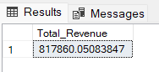

**2. Average Order Value:**

SELECT (SUM(total_price) / COUNT(DISTINCT order_id)) AS Avg_order_Value FROM pizza_sales

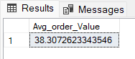

**3. Total Pizzas Sold:**

SELECT SUM(total_price)/ COUNT(DISTINCT order_id) AS Total_pizza_sold FROM pizza_sales

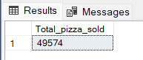

**4. Total Orders:**

SELECT SUM(quantity) AS Total_Orders FROM pizza_sales

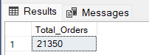

**5. Average Pizzas Per Order:**

SELECT CAST(CAST(SUM(quantity) AS DECIMAL (10,2)) / CAST(COUNT(DISTINCT order_id)

AS DECIMAL(10,2)) AS DECIMAL (10,2)) AS Avg_Pizza_per_order FROM pizza_sales

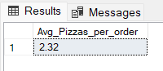

**B. SQL QUERIES**

**1. Daily Trend for Total Pizzas Sold:**

SELECT DATENAME(DW, order_date) AS Order_Day, COUNT(DISTINCT order_id) AS Total_Orders FROM pizza_sales

GROUP_BY DATENAME(DW, order_date)

***Output:***

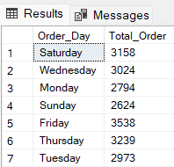

**2. Monthly Trend for Total Pizzas Sold:**

SELECT DATENAME(MONTH, order_date) AS Month_Name, COUNT(DISTINCT order_id) AS Total_Orders FROM pizza_sales

GROUP BY DATENAME(MONTH, order_date)

ORDER BY Total_Orders DESC

***Output:***

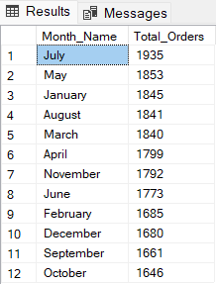

**3. Percentage of Sales by Pizza Category:**

SELECT pizza_category, SUM(total_price) AS Total_Sales, SUM (total_price) * 100 /

(SELECT SUM(total_price) FROM pizza_sales

WHERE MONTH(order_date) = 1) AS PCT FROM pizza_sales

WHERE MONTH(order_date) = 1

GROUP BY pizza_category

***Output:***

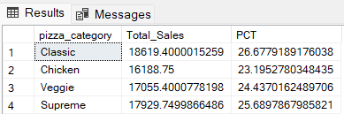

**4. Percentage of Sales by Pizza Size:**

SELECT pizza_size, SUM(total_price) AS Total_Sales, SUM(total_price) * 100 /

(SELECT SUM(total_price) FROM pizza_sales) AS PCT FROM pizza_sales

GROUP BY pizza_size

***Output:***

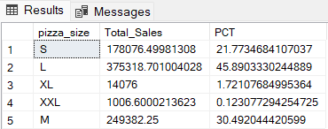

OR

SELECT pizza_size, CAST(SUM(total_price) AS DECIMAL(10,2)) AS Total_Sales, CAST(SUM(total_price) * 100 / (SELECT SUM(total_price) FROM pizza_sales) AS DECIMAL(10,2)) AS PCT FROM pizza_sales

GROUP BY pizza_size

ORDER BY PCT DESC

***Output:***

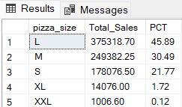

**5. Total Pizzas Sold by Pizza Category:**

SELECT pizza_category, SUM(quantity) as Total_Quantity_Sold FROM pizza_sales

GROUP BY pizza_category

ORDER BY Total_Quantity_Sold DESC

***Output:***

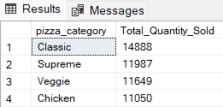

**6. TOP 5 Pizzas by Revenue:**

SELECT TOP 5 pizza_name, SUM(total_price) AS Total_Revenue FROM pizza_sales

GROUP BY pizza_name

ORDER BY Total_Revenue DESC

***Output:***

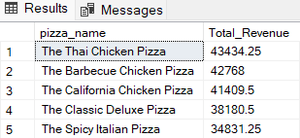

**7. BOTTOM 5 Pizzas by Revenue:**

SELECT TOP 5 pizza_name, SUM(total_price) AS Total_Revenue FROM pizza_sales

GROUP BY pizza_name

ORDER BY Total_Revenue ASC

***Output:***

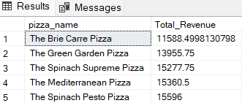

**8. TOP 5 Pizzas by Quantity:**

SELECT TOP 5 pizza_name, SUM(quantity) AS Total_Quantity FROM pizza_sales

GROUP BY pizza_name

ORDER BY Total_Quantity DESC

***Output:***

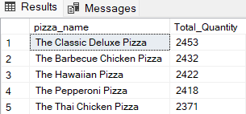

**9. BOTTOM 5 Pizzas by Quantity:**

SELECT TOP 5 pizza_name, SUM(quantity) AS Total_Quantity FROM pizza_sales

GROUP BY pizza_name

ORDER BY Total_Quantity ASC

***Output:***

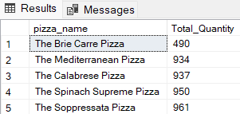

**10. TOP 5 Pizzas by Total Orders:**

SELECT TOP 5 pizza_name, COUNT(DISTINCT order_id) AS Total_Orders FROM pizza_sales

GROUP BY pizza_name

ORDER BY Total_Orders DESC

***Output:***

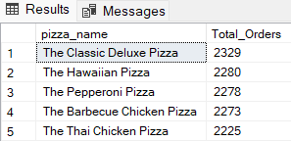

**11. BOTTOM 5 Pizzas by Total Orders:**

SELECT TOP 5 pizza_name, COUNT(DISTINCT order_id) AS Total_Orders FROM pizza_sales

GROUP BY pizza_name

ORDER BY Total_Orders ASC

***Output:***

